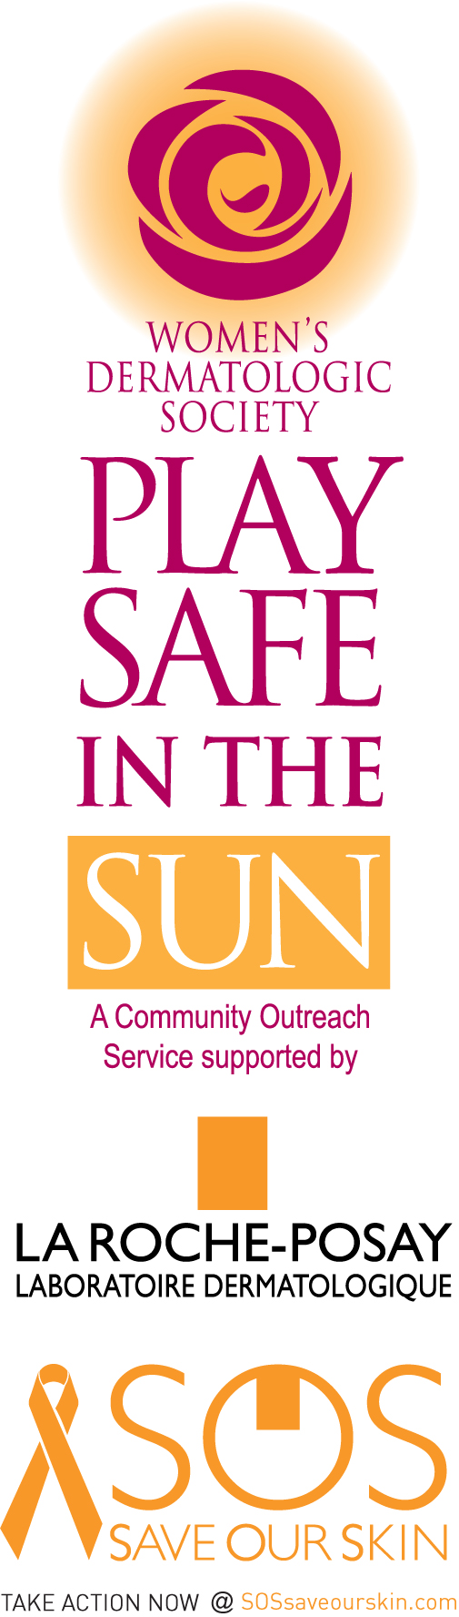

10 Tips for Enhancing your Coast-to-Coast Play Safe in the Sun Presentation/Outreach

- Bring props to help tell the sun safety story. Include: wide-brimmed hats, UVA/UVB protective sunglasses, sun protective clothing, sun umbrella, Sun Guard ® for the laundry (if available) and a variety of sunscreen/sunblock vehicles (gels, creams, lotions, sprays, sticks, lip balm, SPF make-up).

- Incorporate visuals showing sun damaged skin and different types of skin cancers to help audience recognize the signs.

- Bring a handheld mirror to show people how to self-examine those hard-to-see places.

- Demonstrate what the proper amount of sunscreen per application looks like. Use a golf ball or ping-pong ball, a shotglass, or squeeze out the right amount of sunscreen for the audience. Address proper application and re-application techniques.

- Use the latest statistics to demonstrate the epidemic proportions of skin cancer affecting different populations. Emphasize that while skin cancer is the most common form of cancer in the nation, it is also the most preventable. It is never too late or too early to protect the skin.

- Invite questions and interaction with the audience.

- Invite local media to cover your educational presentation. For tips and assistance, contact WDS Director of Communications Nancy FitzGerald: nfitzgerald@womensderm.org.

- Visit www.playsafeinthesun.org/coast2coast for downloadable resources to print out and distribute.

- A courtesy box of broad-spectrum sunscreen will be furnished to you by our program supporter, La Roche-Posay when you sign up for your toolkit to distribute to the participants.

10. Photograph your event and let us know about it for the next newsletter.

Thank you for volunteering in your community to educate the public about sun safety and skin cancer prevention!

